**A Project Report**

**On**

**“RoomShare – A Roommate finding application”**

**Group Members**

**Exam Number Name of the Students**

T150028516 Chuttar Tejas Manoj

T150028547 Kondawar Yash Manish

T150028570 Sharma Dhanur Jeetendra

**Under the Guidance of**

Mrs. Sheetal Girase

Mrs. Varsha Powar-Naik

**Subject**

Database Management Systems Laboratory

SL-I



**Department Of Information Technology**

**Maharashtra Institute of Technology, Pune**

**Academic Year**

2016-2017



***Certificate***

**This is to certify that the group of following students of third year has successfully completed their project on “ RoomShare – A roommate finding application“ for the partial fulfillment of SL-I Mini Project in Information Technology awarded by Maharashtra Institute of Technology, Pune during academic year 2017-18.**

**Submitted By**

Yash Manish Kondawar

Tejas Manoj Chuttar

Dhanur Jeetendra Sharma

**Guide Name Head of Department Mrs.Sheetal Girase**

**Mrs.Varsha Powar**

**External Examiner**

**Acknowledgement**

We have taken efforts in this projects. However, it would not have been possible without Kind support and help of many individuals. We would like to extend our sincere thanks to all of them.

We are highly indebted and sincerely thanks **Mrs.Varsha Powar**, Class Teacher of TE-IT for her guidance and constant supervision as well as for providing necessary information regarding the topic & also for his support in completing the work.

We would like to express our gratitude towards **Mrs.Sheetal Girase**, SL-I project coordinator for her co-operation and encouragement which help us in completion of this project.

Our thanks and appreciations also go to our parents, colleagues, friends and people who have knowingly helped us out with their abilities.

Yash Manish Kondawar

Tejas Manoj Chuttar

Dhanur Jeetendra Sharma

INDEX

1. Problem Statement.

2. Introduction.

3. Project Scope.

4. Project Assumptions.

5. Requirement Specifications.

6. System Design

7. Implementation

8. Test Case and Screenshots

1. Problem Statement

1."RoomShare" provides services to people who don't have a flat, to find a roommate they'll be comfortable living with in flat they like.

2.The person currently living in a flat, decides the person he'll be comfortable living with based on the following details :

Sex

Smoking

Drinking

Travelling

Pets

Occupation

Eating habits

Age

Parties

Visitors

Cook/mess

Caste

Origin

3.Additionally, we shall save the names, login details, date of birth, contact details, and we shall assign a unique ID to each.

4.We shall also be requiring the budget, stay period, and the area they'd want to stay for the person without the flat.

5.The person without flat enters the username of his friend which provided him suggestion of the people his had previously liked.

6.For the person with the flat, a number of roommates live with him, each of who's details are stored as well.

7.Every person with the flat provides the details such as Address, Size, total rent, deposit, vacancy, parking, security, backup, ac, furnished, water supply, availability, and images of the flat.

8. Feedback will be given by the people which will involve a rating, comments and suggestions for further development.

2. Introduction

The RoomShare application is a unique platform that helps you find not only suitable flats but also roommates of your choice. The website has two types of users that which are : 1) Person with flat and 2) Person without flat. New user has to create an account by signing up. Then he can login with given username and password. After logging in the user is redirected to the respective home pages. The person without flat gets a page to select the filters and then respective flat and person is displayed with cards. If the person likes that profile, then his card is displayed to the person with flat and if he likes him back, only then a match is found and the contacts and names are exchanged. This way the privacy is also maintained and private information is not disclosed to strangers. This is the only website which compares qualities of the people according to the choices they select and then according to the percentage of matching of qualities (based on critical and non-critical attributes ) , the perfect roommate and flat is found. Anyone who is new to any city and is finding a place to live is eligible to use this platform.

**GLOSSARY:**

|  |  |
| --- | --- |
| **Term** | **Definition** |
| PWF / PWOF | Person with flat / Person without flat |
| Critical attributes | The quality that matters most in person you are finding. |
| Liked profiles | When a person without flat likes a profile then it gets displayed under liked profiles. |
| Matched profiles | When person without flat likes someone back, then he gets displayed under matched profile for person without flat. |
|  |  |

3. Project Scope

The scope of the project is to find better compatible roommates and flats for people moving into metro cities for work or studies. But the scope can be expanded to all over India and also abroad with a little updated version.

Currently there are websites which help you find flats but after the search for flats is done then the search for roommates starts. And even after that people have to adjust according to the roommate they find. But our website first finds you a perfect person to live with and if you like his flat too, then a match is found. The current websites also has limited information of the flat but our website contains every single necessary detail from rent and deposit to parking availability.

4. Project Assumptions

➔ The person with flat uses only our website to find roommates and so the number of roommate doesn’t change from creation of account till the match is found.

➔ All the users have proper technologies to access our website.

➔ All the users are either finding a flat or have a flat and finding a roommate. No other type of account is available and neither can a person be in both types.

➔ The person with flat and all his roommates use the same login account from same username and password.

5. Requirement Specifications

Requirement analysis help the software engineer to better understand the problem they will work to solve. It includes the set of tasks that lead to an understanding:-

1. What customer wants exactly?

2. What is the information proposed by the system?

3. What function the systems perform?

4. What is the behaviour of the system?

**5.1 HARDWARE REQUIREMENTS:**

* A Windows/Linux compatible LAN Network
* Processor P4
* At least 512 megabytes (MB) RAM
* A Pentium 600 MHz PC (or faster)
* PDA device or simulator for PDA

**5.2 SOFTWARE REQUIREMENTS:**

* Operating system(win xp,vista,7,Linux,mac)
* MySQL
* Appache Tomcat server
* Xampp server

**5.3 PRODUCT FEATURE:**

The most important feature of RoomShare application is liking and matching of profiles. Another important feature is percentage matching based on critical and non-critical attributes of person with flat and all the roommates. The cards with appropriate filters are displayed according to descending order of percentages. The referral page allows you to see the profiles liked by the entered username.

Theperson without flat has:

1. Filters for selection of profiles based on attribute.
2. Liked profiles.
3. Referal page
4. Matched profiles.
5. Edit profiles.
6. Logout Button.

Theperson with flat has:

1. Liked profiles.
2. Matched profiles.
3. Edit profile.
4. Logout Button.

**5.4 COST ESTIMATION OF PROJECT:**

Effective software project estimation is one of the challenging and important activities in software development. Proper project planning and control is not possible without sound and reliable estimate.

The four basic steps in software project estimation are:

1. Estimate the size of development product. The units of measure are lines of code (LOC) and function point (FP).
2. Estimate the effort in person-months or person-hours.
3. Estimate the schedule in calendar months.
4. Estimate the project cost in rupees.

Estimated Cost for Development

|  |  |
| --- | --- |
| Total number of persons working on project | 3 |
| Time taken in months | 3 |
| Total time allotted per day in terms of hour | 1.5 hrs |
| Actual working hours (60*2 hours) | 135 |
| Cost per hours | 125 |
| **Total estimated project cost is: (120*150)** | **Rs. 16,875/-** |

**6. SYSTEM DESIGN**

**DATABASE ARCHITECTURE**

The design of a DBMS depends on its architecture. It can be centralized or decentralized or hierarchical. The architecture of a DBMS can be seen as either single tier or multi-tier. An n-tier architecture divides the whole system into related but independent **n** modules, which can be independently modified, altered, changed, or replaced.

In 1-tier architecture, the DBMS is the only entity where the user directly sits on the DBMS and uses it. Any changes done here will directly be done on the DBMS itself. It does not provide handy tools for end-users. Database designers and programmers normally prefer to use single-tier architecture.

If the architecture of DBMS is 2-tier, then it must have an application through which the DBMS can be accessed. Programmers use 2-tier architecture where they access the DBMS by means of an application. Here the application tier is entirely independent of the database in terms of operation, design, and programming.

**Three-tier Client / Server Architecture**

**Block Diagram**

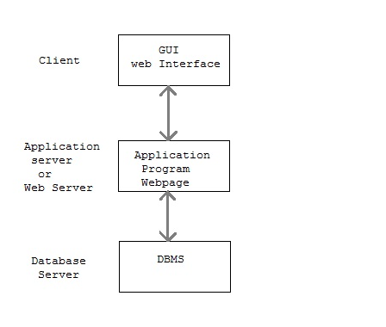

**7. IMPLEMENNTATION**

Analysis part represents the customer requirements e.g. Analysis step includes stepwise specifications of the program or process to represent requirements, analysis includes three domains

* Information domain
* Functional domain
* Behavioural domain

**7.1 Project Work Breakdown structure (Analysis)**

**RoomShare- roommate finding application**

A: Communication

B: Planning

A1: Project initiation

C: Modelling

B2: Project scheduling and tracking

A2: Requirement Gathering

C1: Analysis

B1: Estimation

CS2: Design

**A: Communication:**

Software development process starts with the communication between customer and developer. According to need of project, gathering of the requirements related to project are done.

**B: Planning**:

It includes complete estimation and scheduling (complete timeline chart for project development and tracking shown below.

**C: Modelling:**

It includes detailed requirement analysis and project design as shown in points 5 and 6.

**7.2 PROJECT SCHEDULING AND TRACKING:**

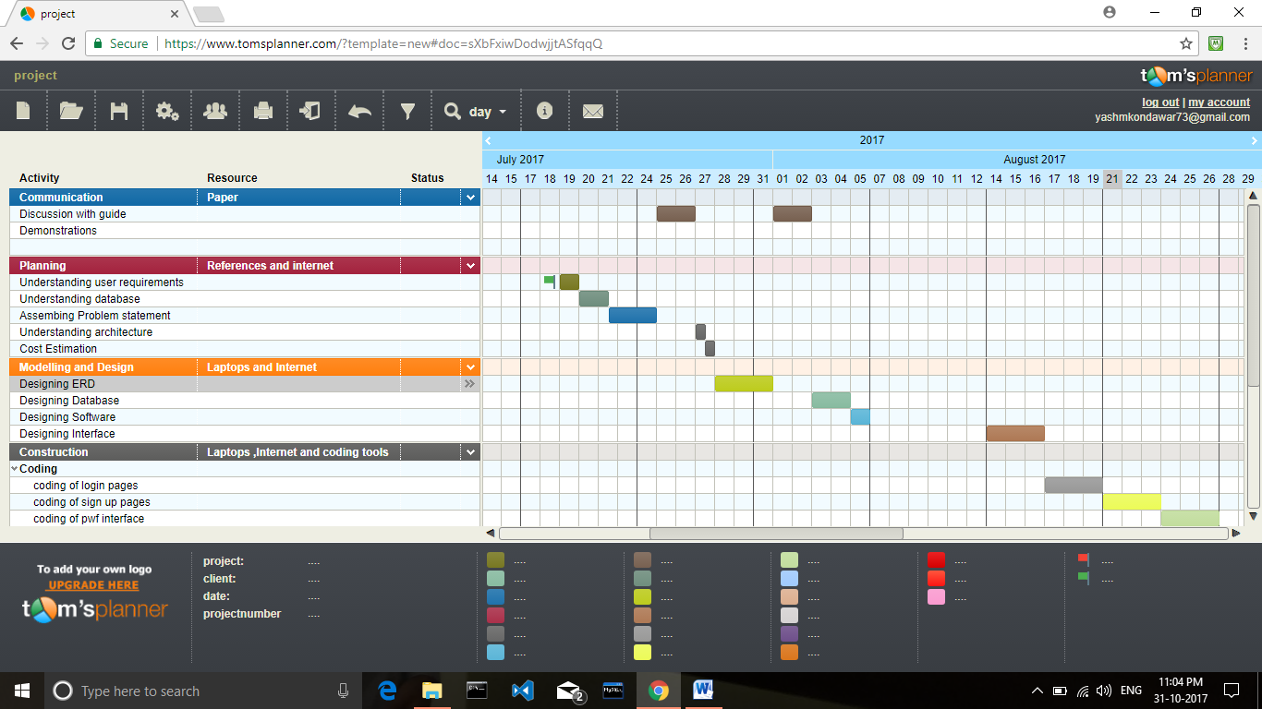

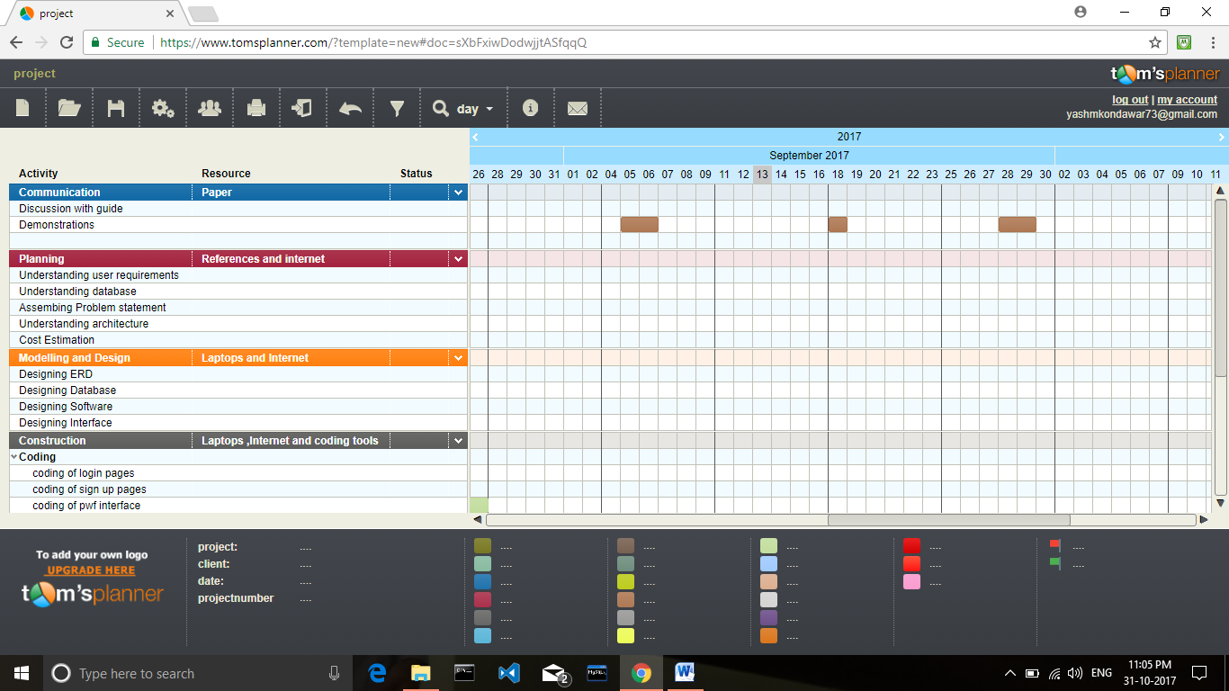

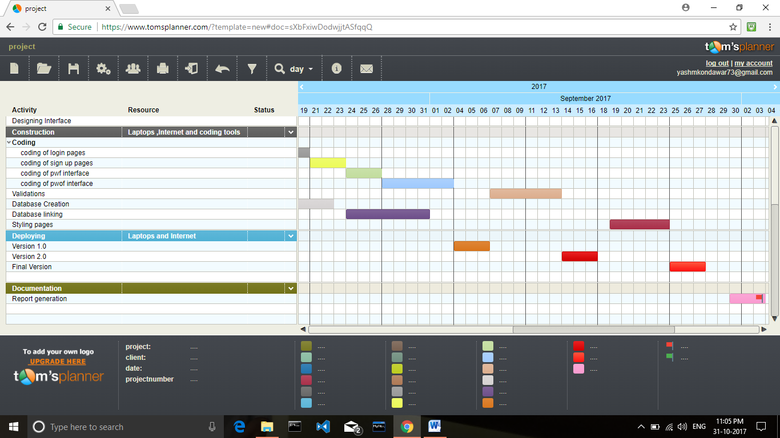

**7.3 Use case Diagram:**

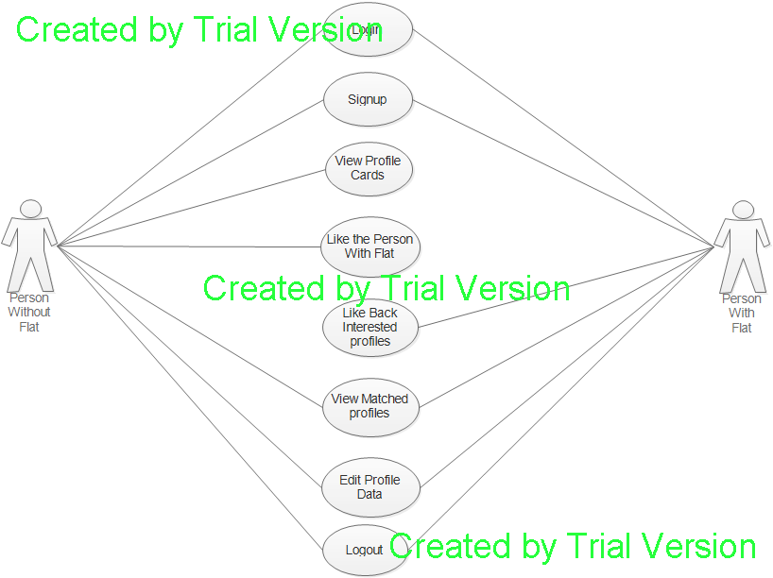

**7.4 Activity Diagram:**

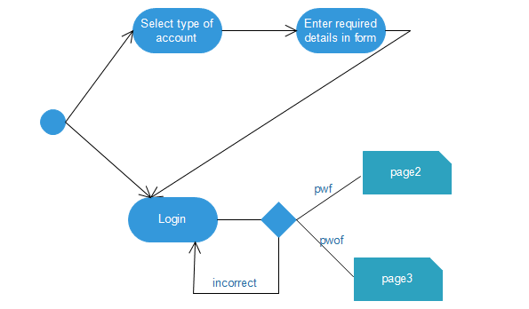

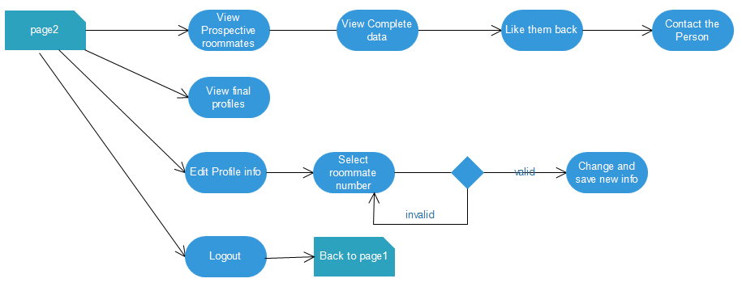

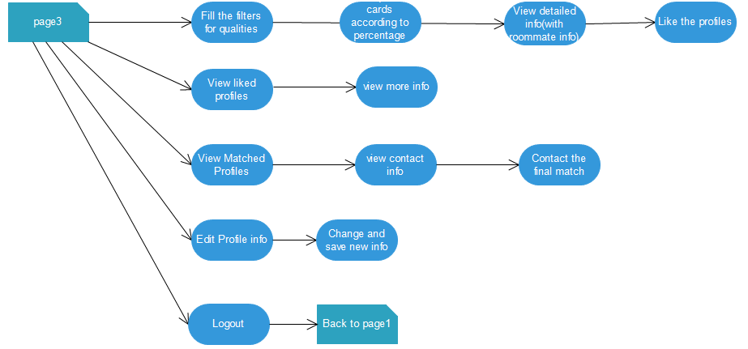

**7.5 Project Work Breakdown Structure (Implementation):**

It includes coding and testing steps. Design details are implemented using PHP, JavaScript and HTML language.

**GUI Design:**

GUI (Graphical user interface) design is important phase in project development .It describe how users interact with system. GUI design is implemented using html, css and JavaScript technology. HTML provides different components like

1: Button

2: list box

3: checkbox

4: frame

5: container

6: radio button

All this component required for developing graphical user interface design of given system. To enhance the quality of design swing component use to develop GUI design.

**A1: Template**

Templates are used to create look and feel for the web application. These are simply downloaded from the web and then changes are made to them according to the user request. Cascading style sheets are used for formatting page layout, text, fonts and images on the page. Cascading style sheets allow to position things on page down to the exact pixel. Also, if a style is declared in the head section of a page, a change to the style changes the style on the entire page.

**A2: Event Handling:**

We used javaScript function for handling event .The functions like onClick(), onChange() etc

**A21: Validation**

This module is design for the purpose of to check whether a particular user is authorized to perform a particular task on the request of the main controller. The validation methods access the database by firing SQL query to the database.

**A3: Database**

Database is created to store the information of the users. MySql database is used as database management system. Beans directly interact with the database to retrieve the information from the database. The whole database is divided into number of tables to reduce the complexity and to increase the performance.

**A31: Database Access**

A Class directly interact with the database to retrieve the information from the database. The whole database is divided into number of tables to reduce the complexity and to increase the performance.

**A4: Integrating Modules**

In this phase all the s/w modules are collected & integrated together.

**A5: Testing and debugging**

Testing is carried out to check whether flow of coding is correct, to check out the errors of required module.

**B: Delivery**

Final delivery of project will be given along with the necessary documentation.

1. **TEST CASE**

Home Page:

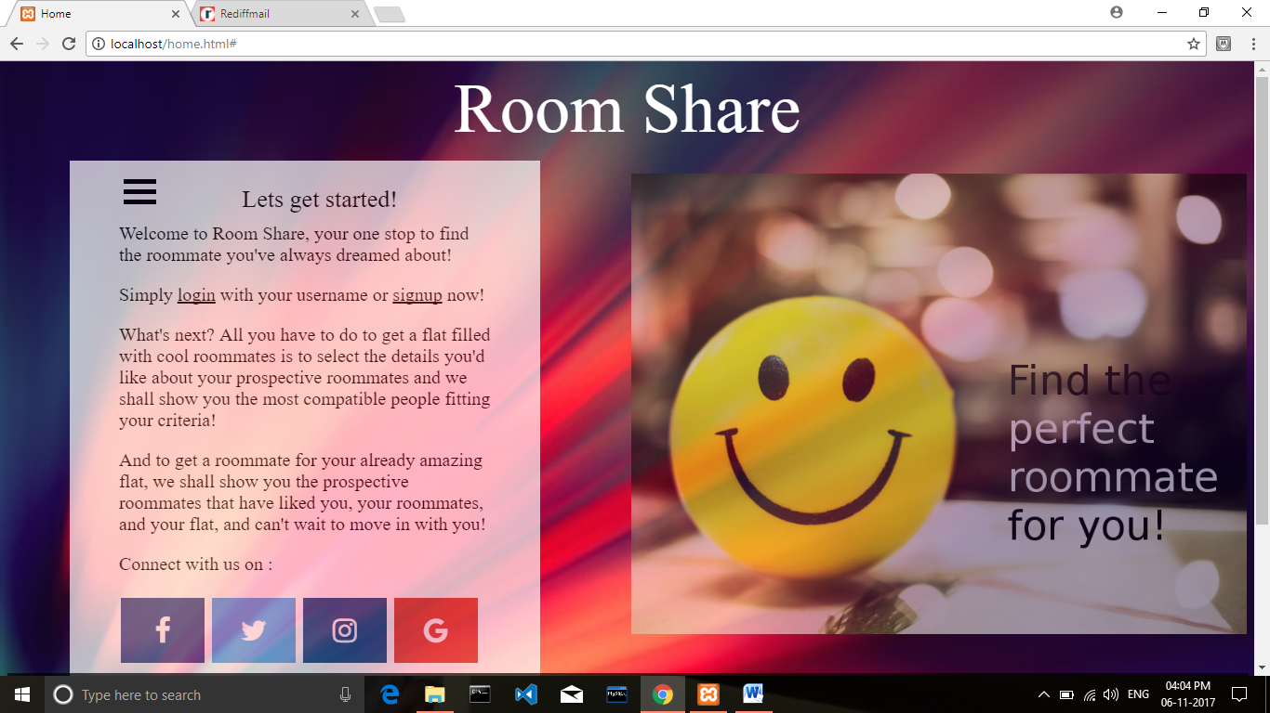

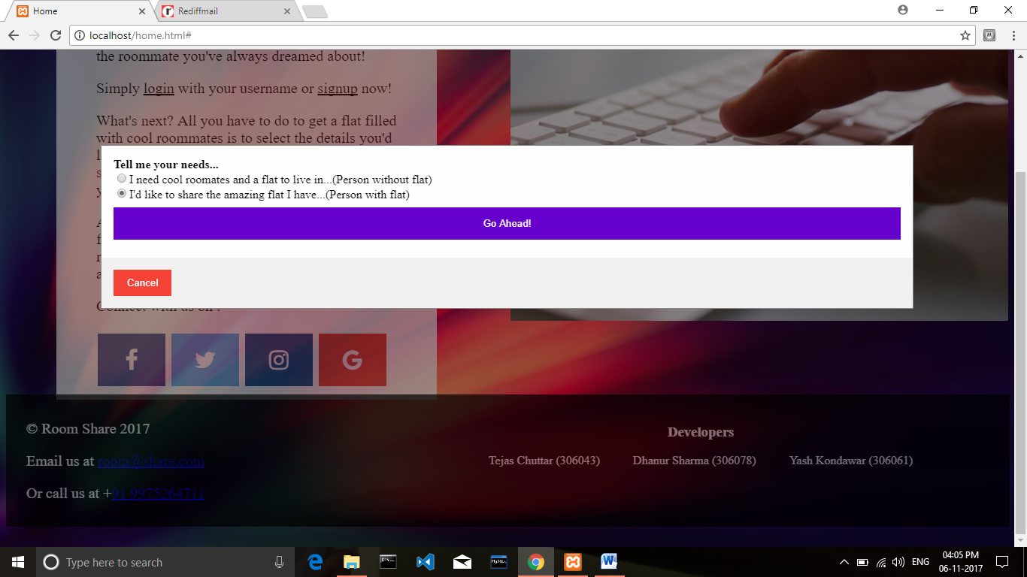

Person With flat entry:

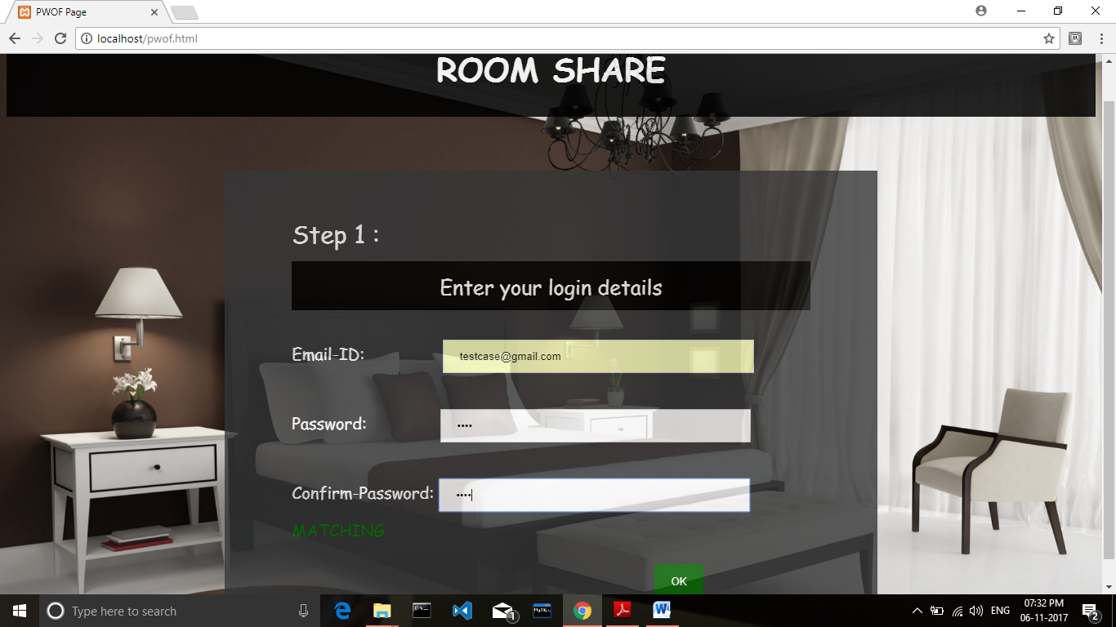

Validations:

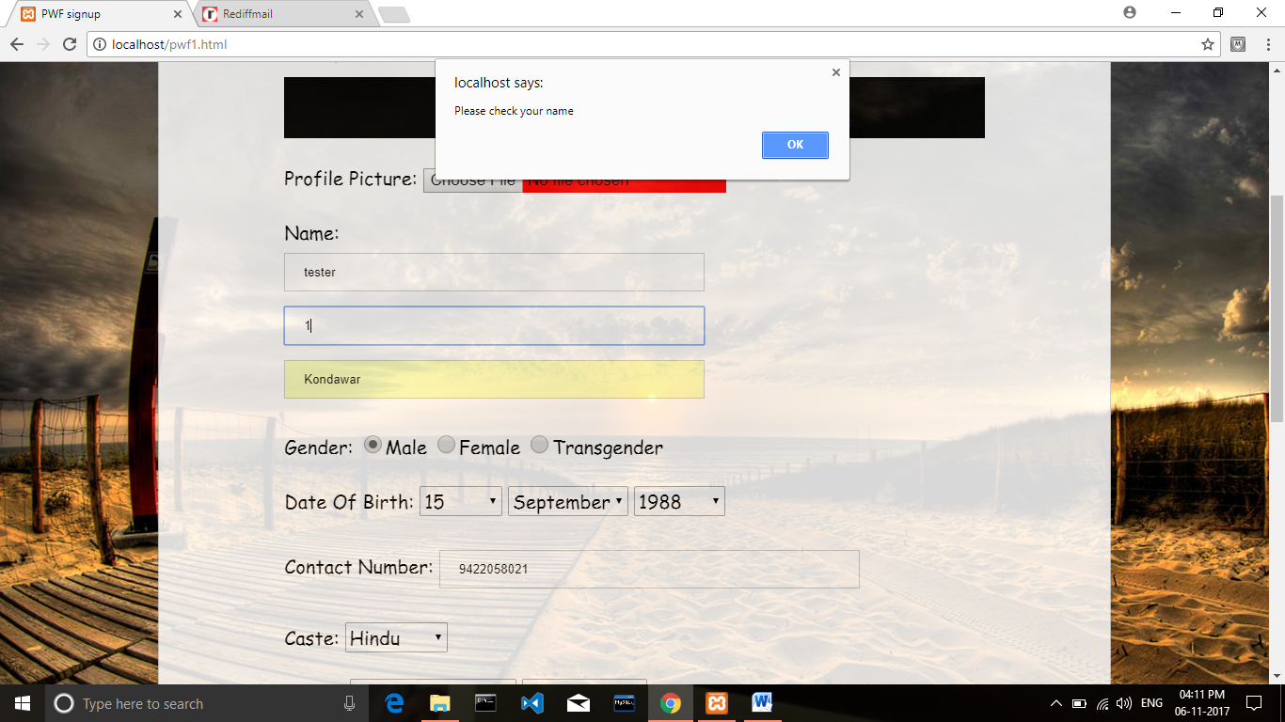

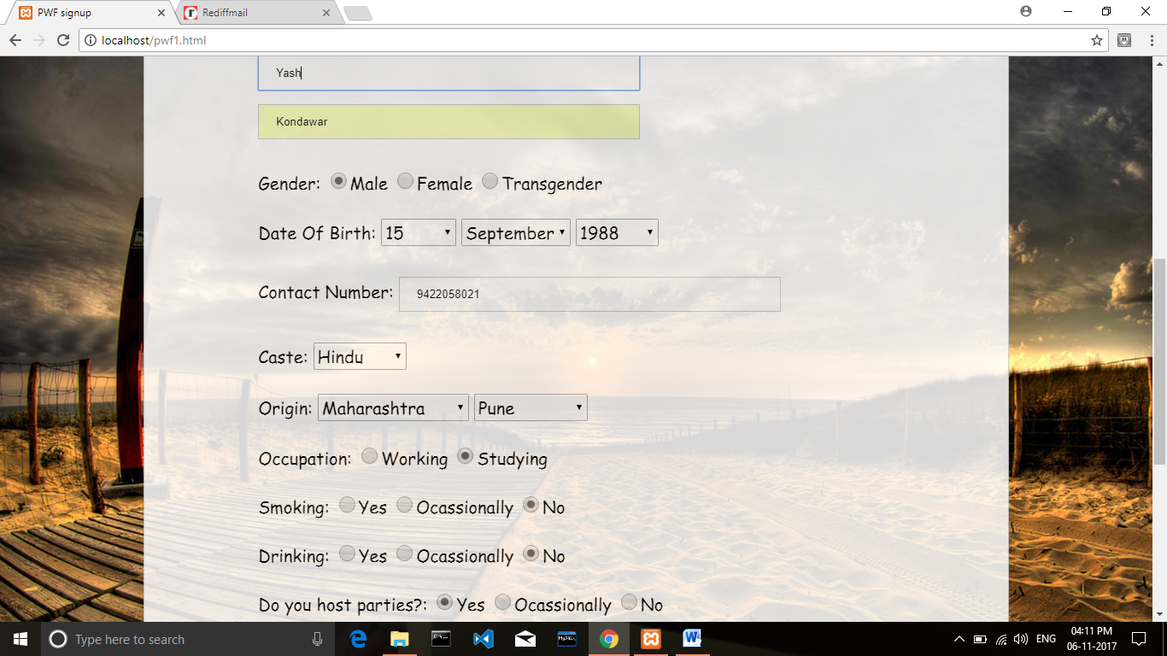

Flat entry:

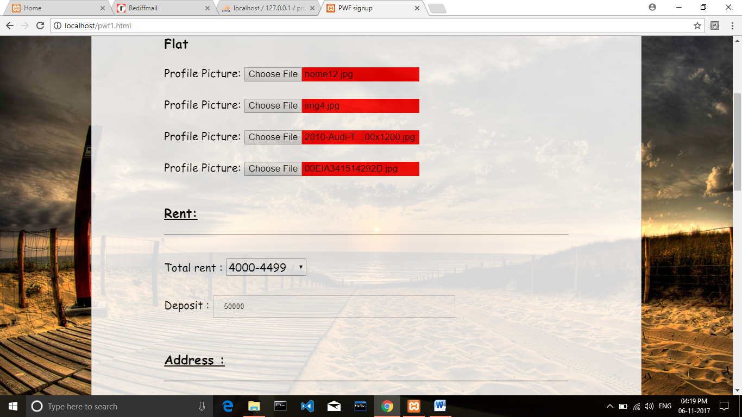

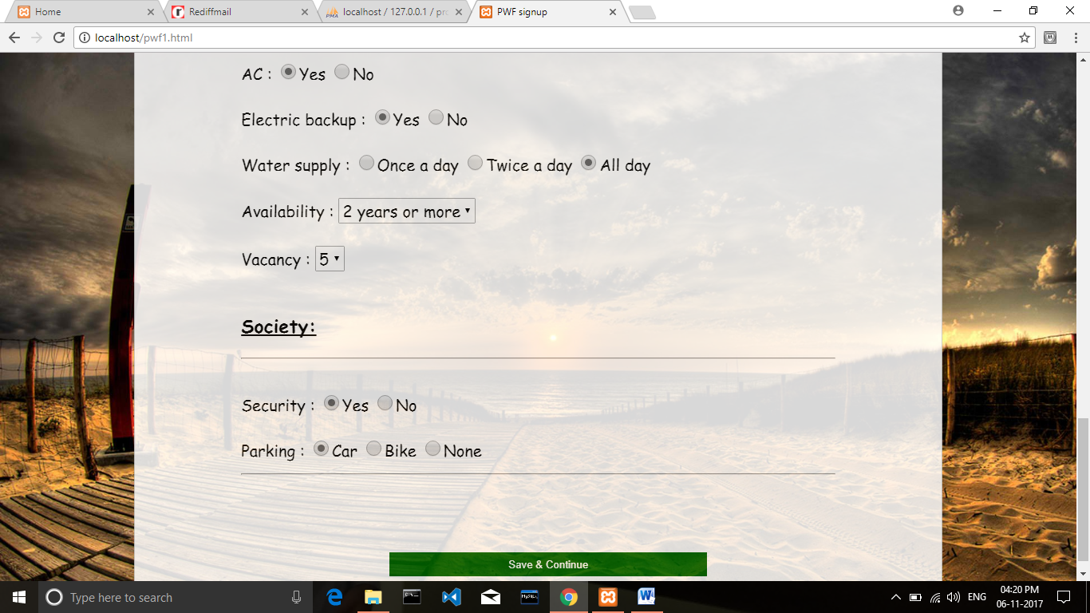

Person Without Flat entry:

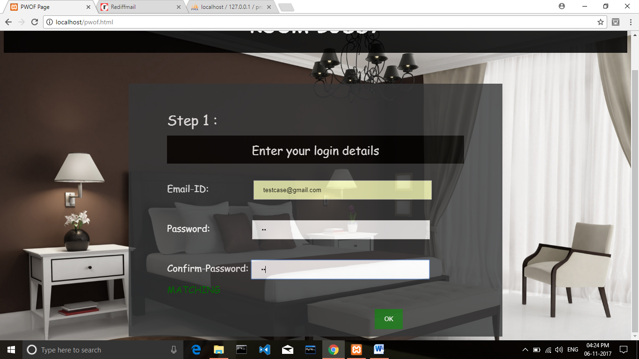

Email Id validation:

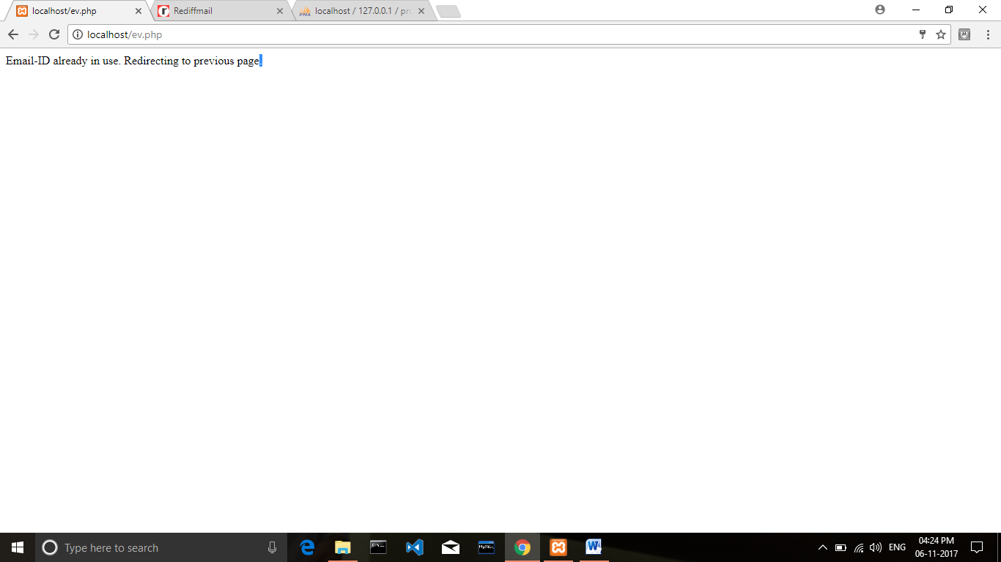

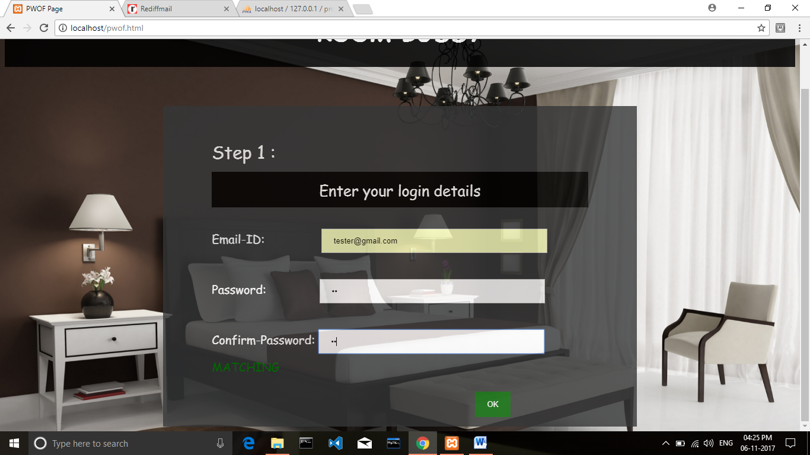

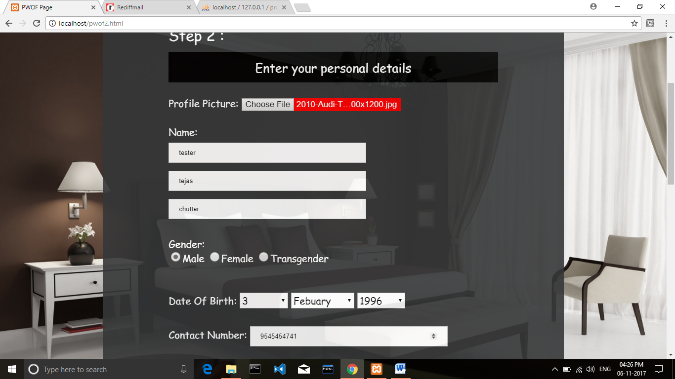

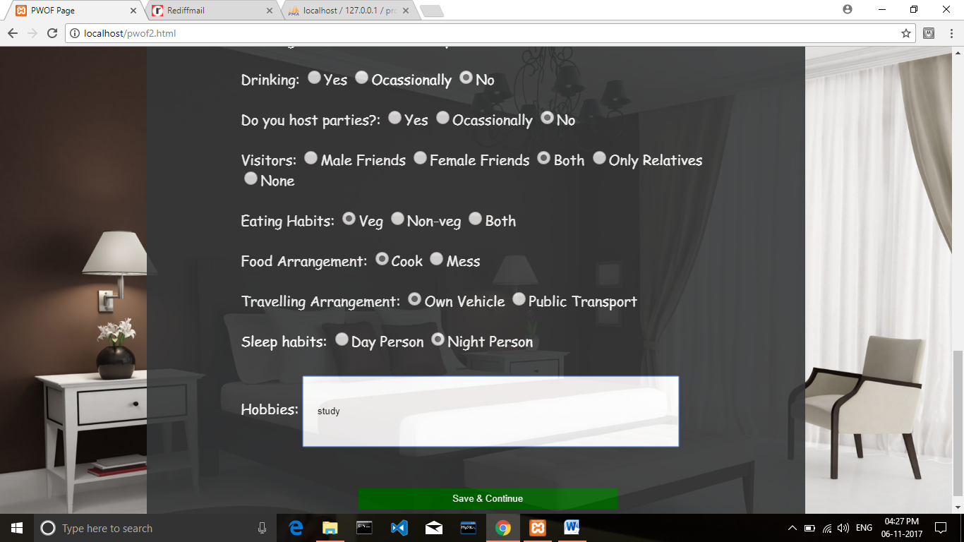

Login [tester@gmail.com](mailto:tester@gmail.com) home:

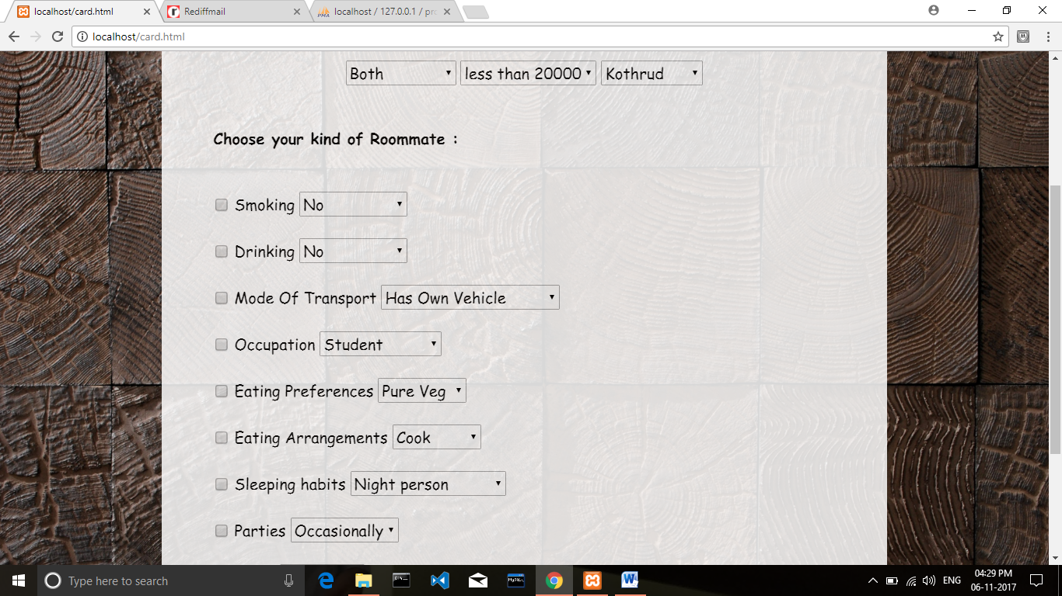

Profile cards display:

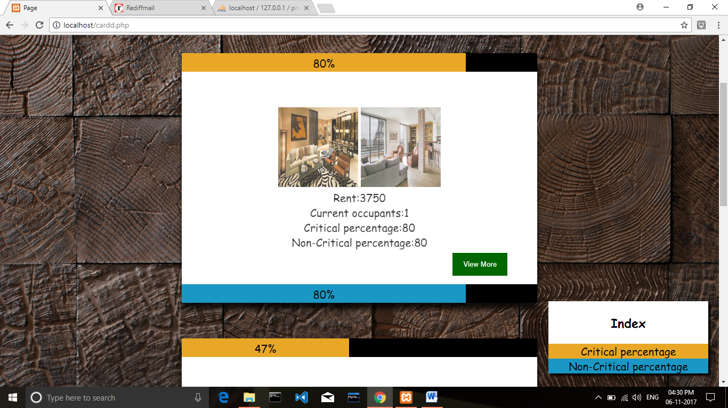

View More about profile and like it:

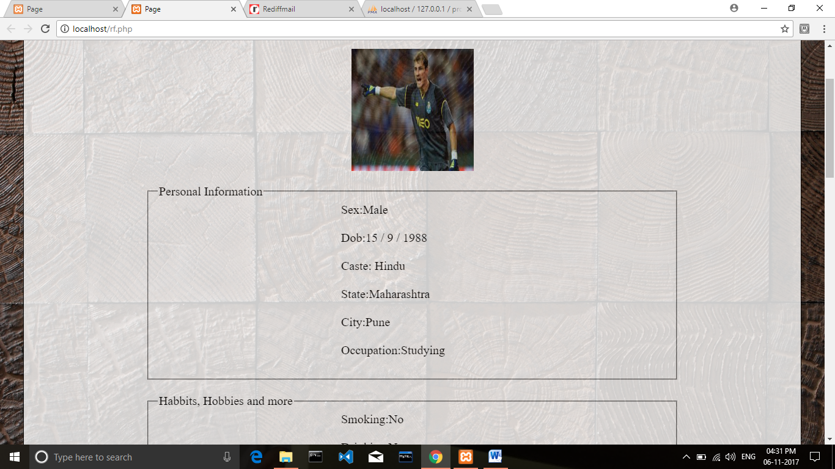

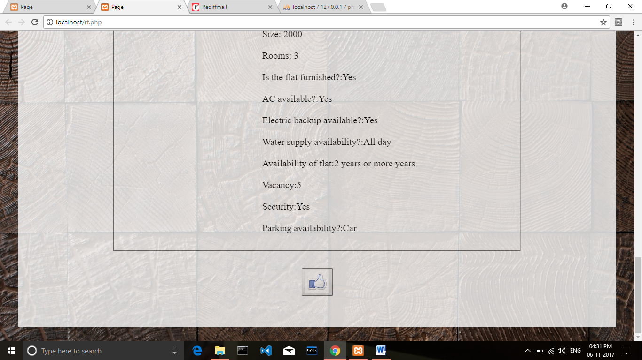

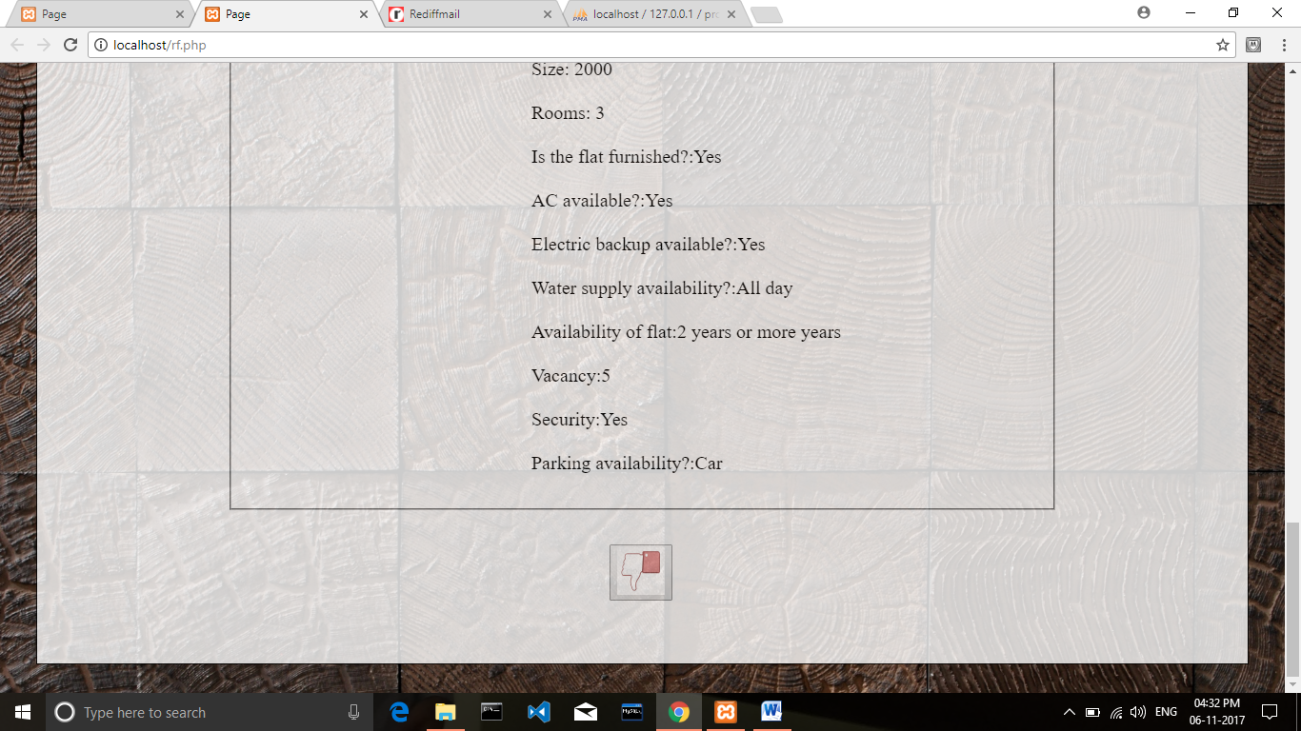

Liked Profiles:

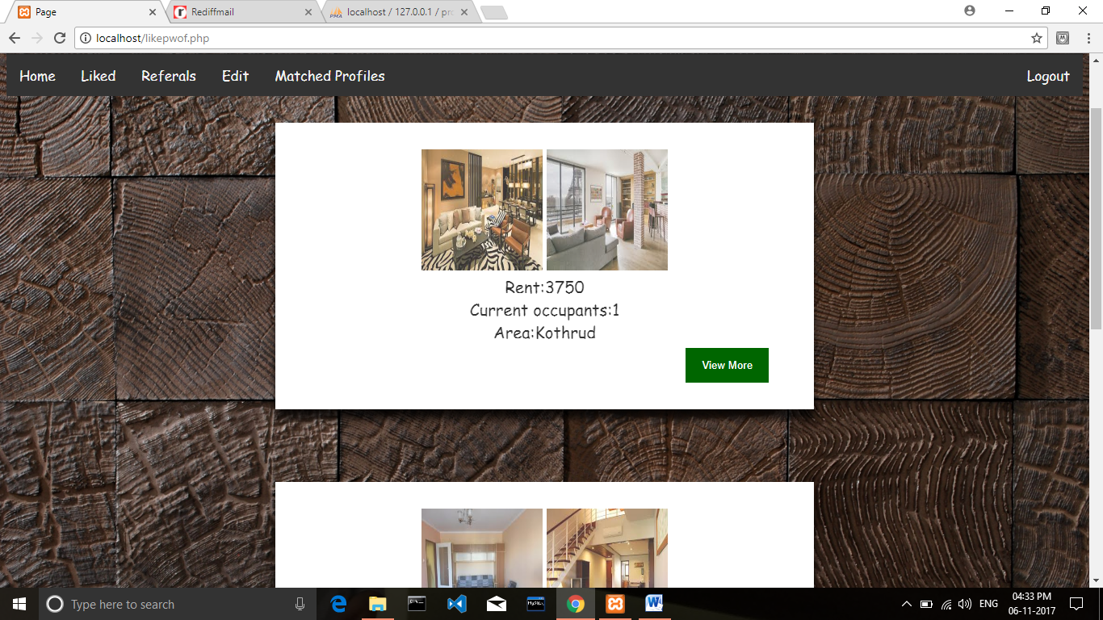

Edit Your Profile:

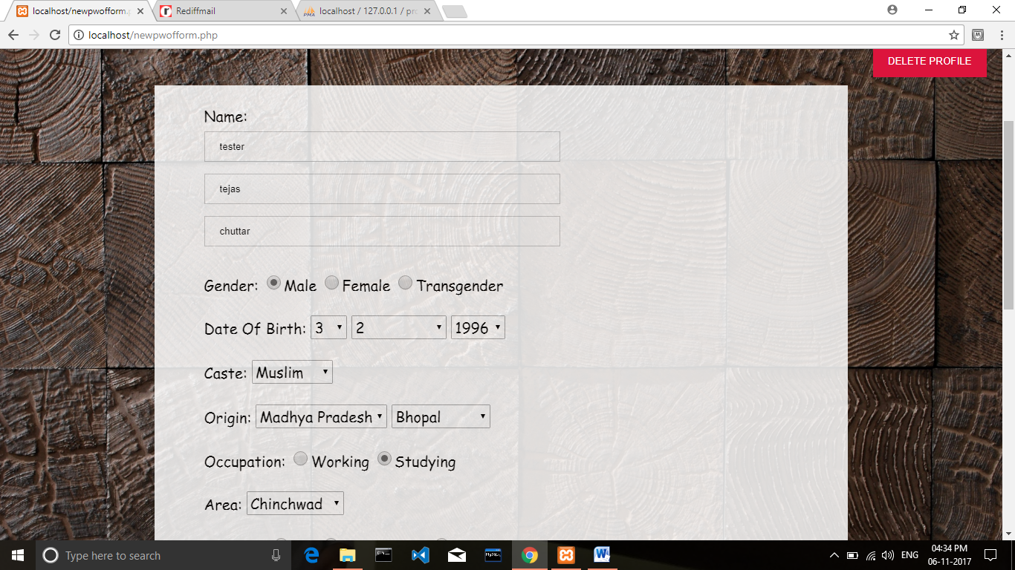

Referral Page:

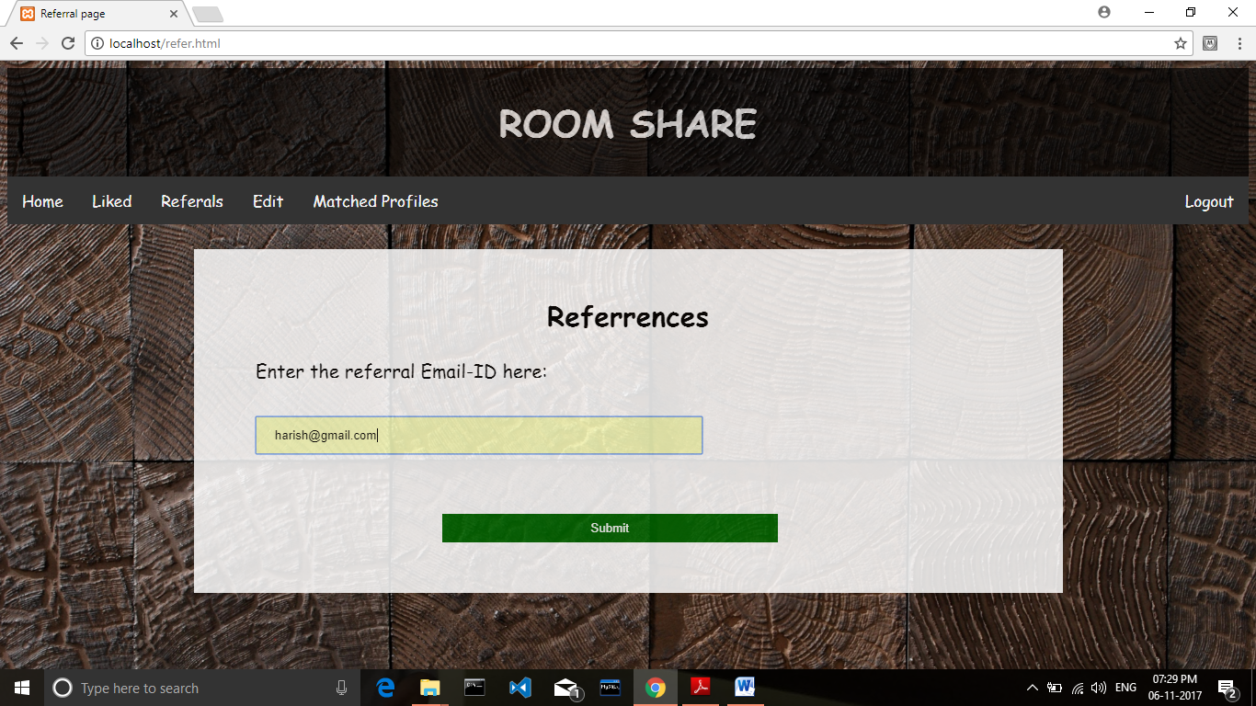

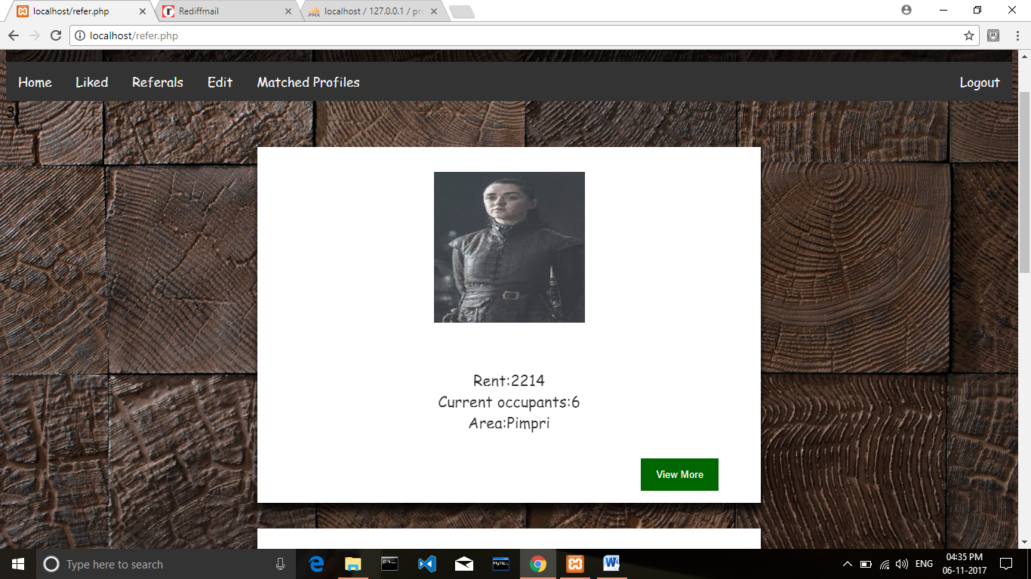

Login [testcase@gmail.com](mailto:testcase@gmail.com) Home:

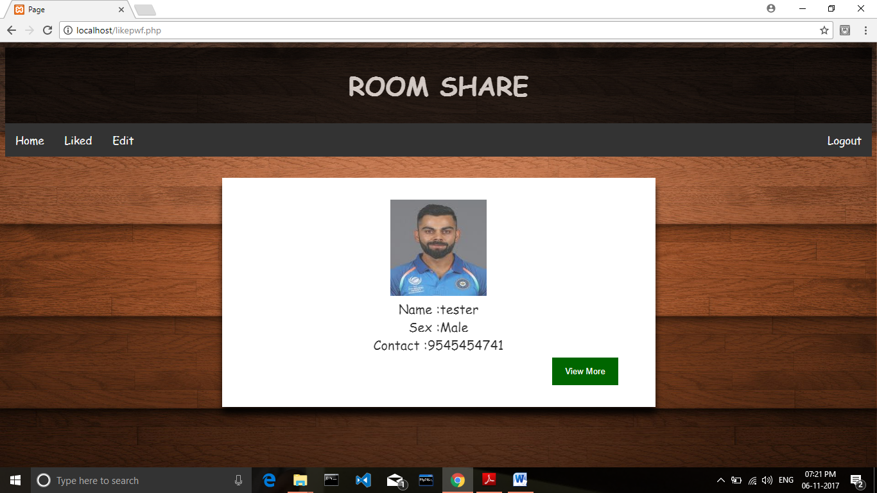

View more:

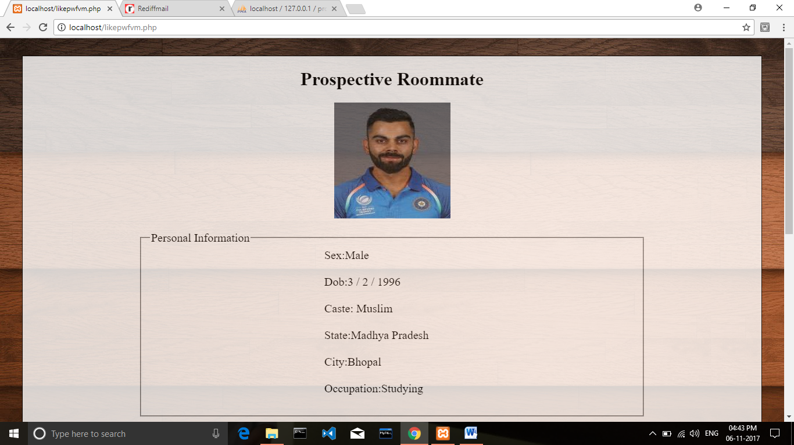

Like Profile:

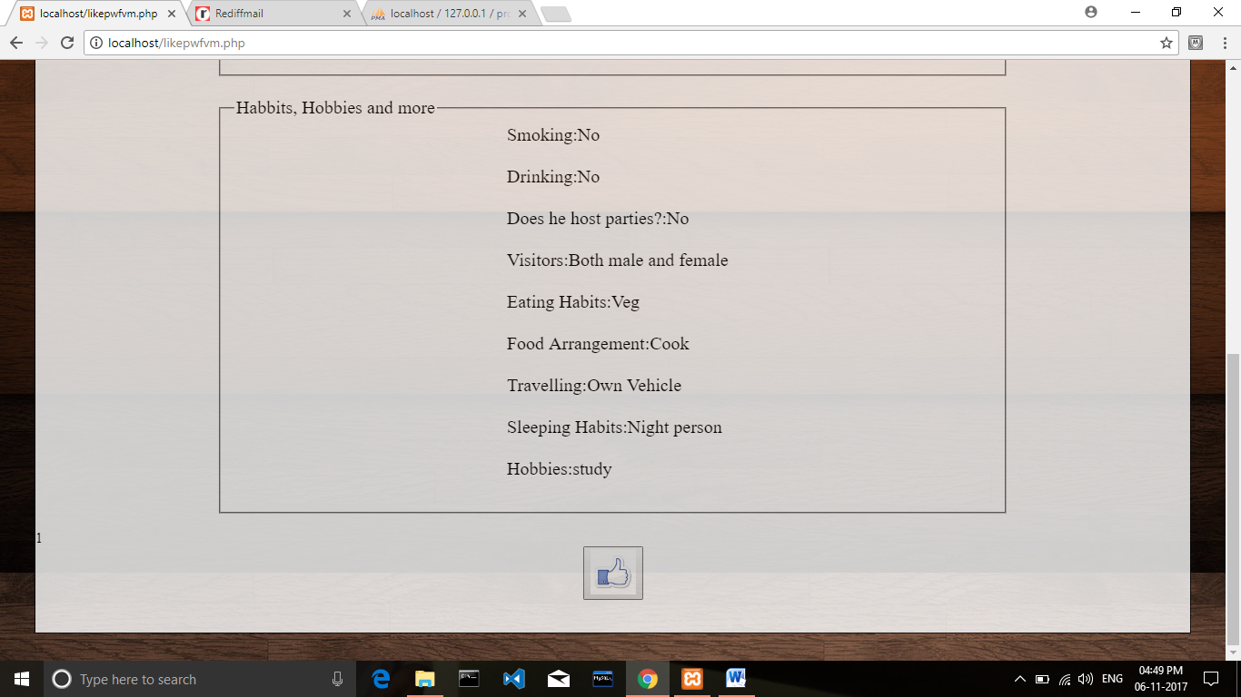

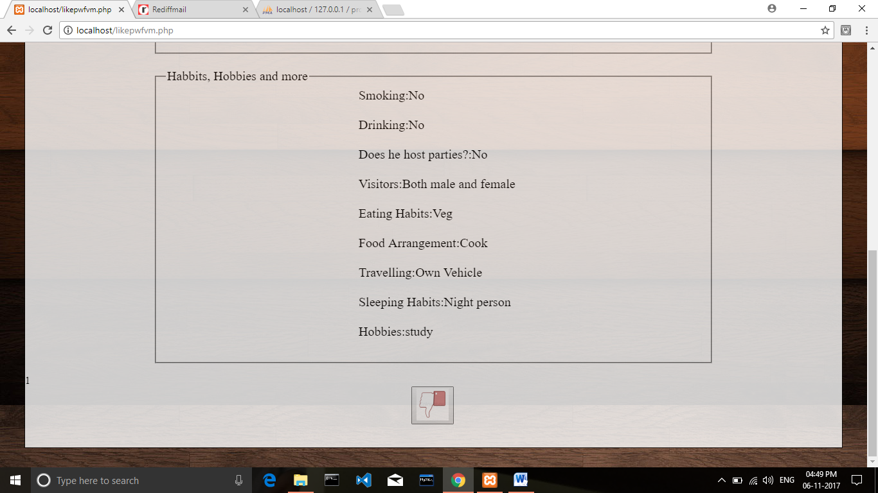

Liked profiles :



Edit Profile and addition or deletion of roommates:

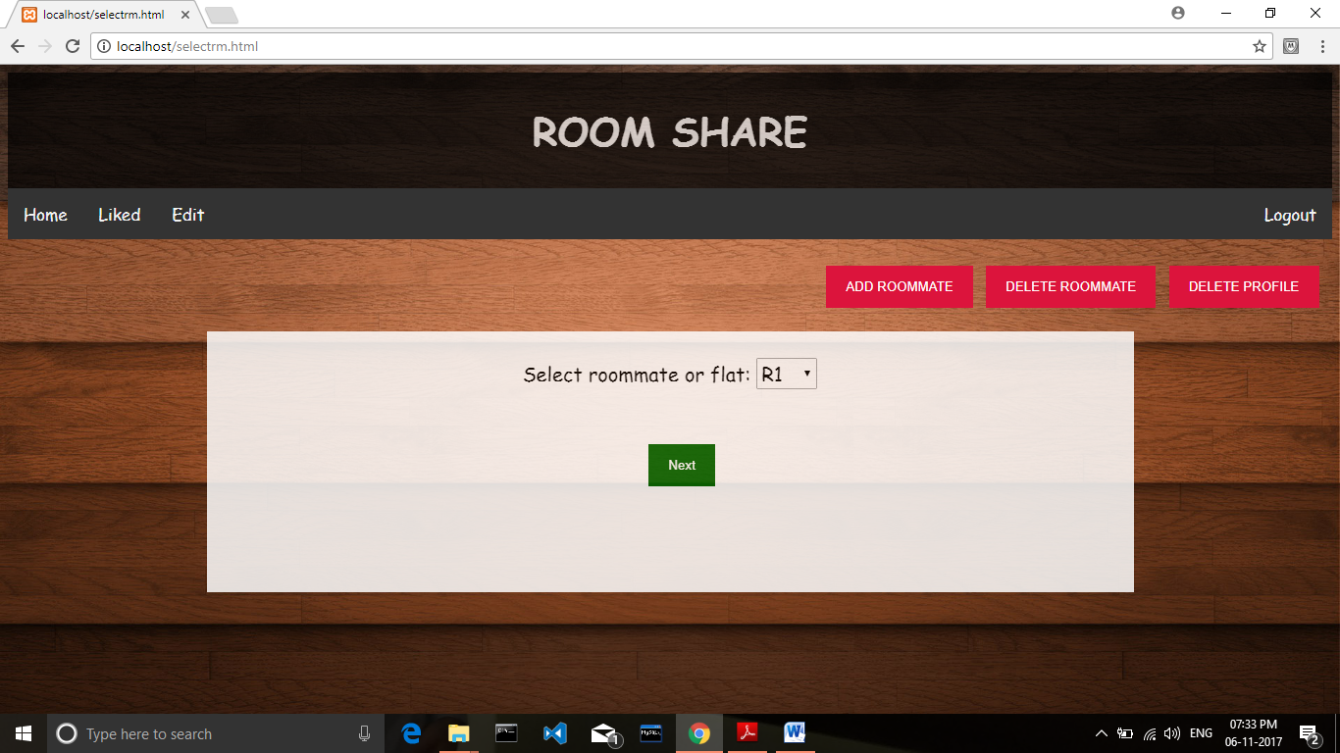

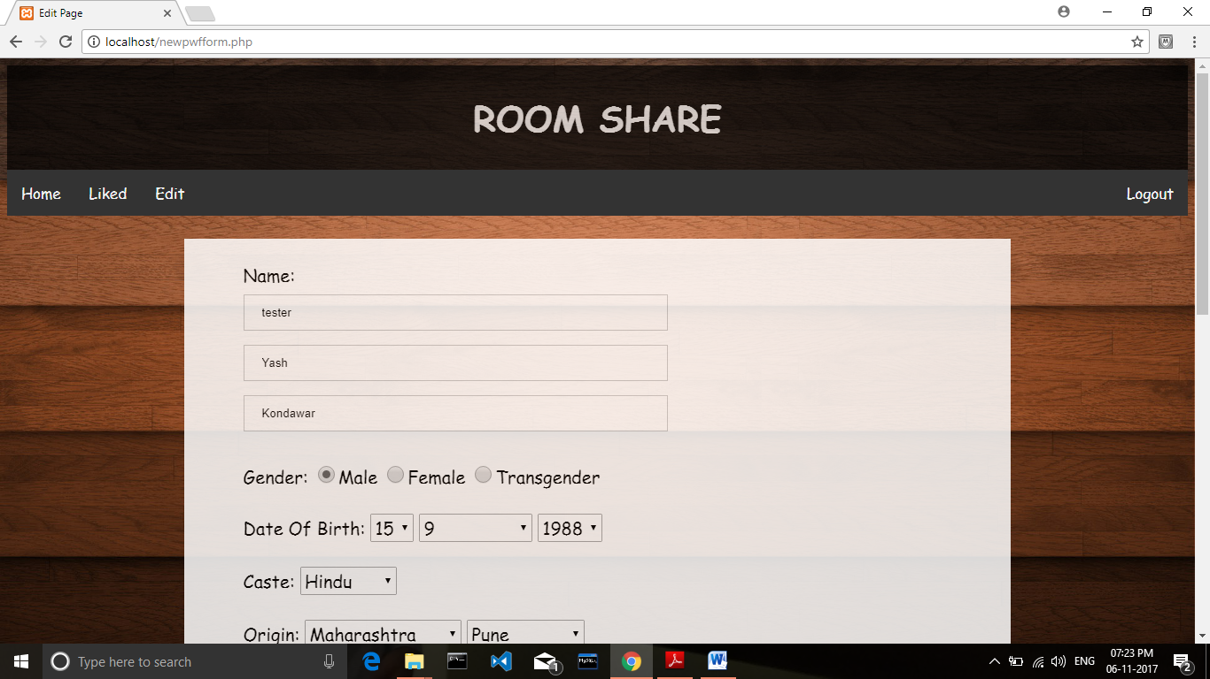

Delete Roommate:

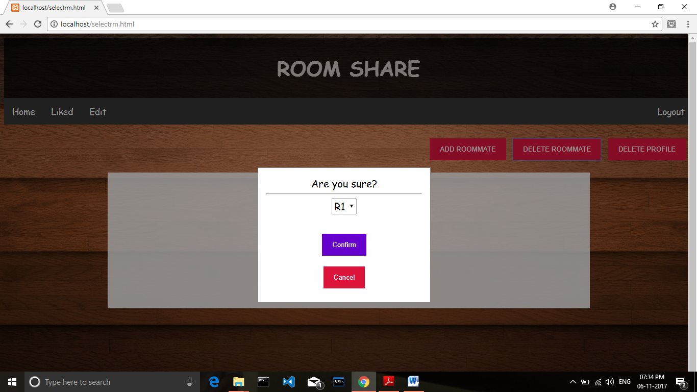

Add roommate:

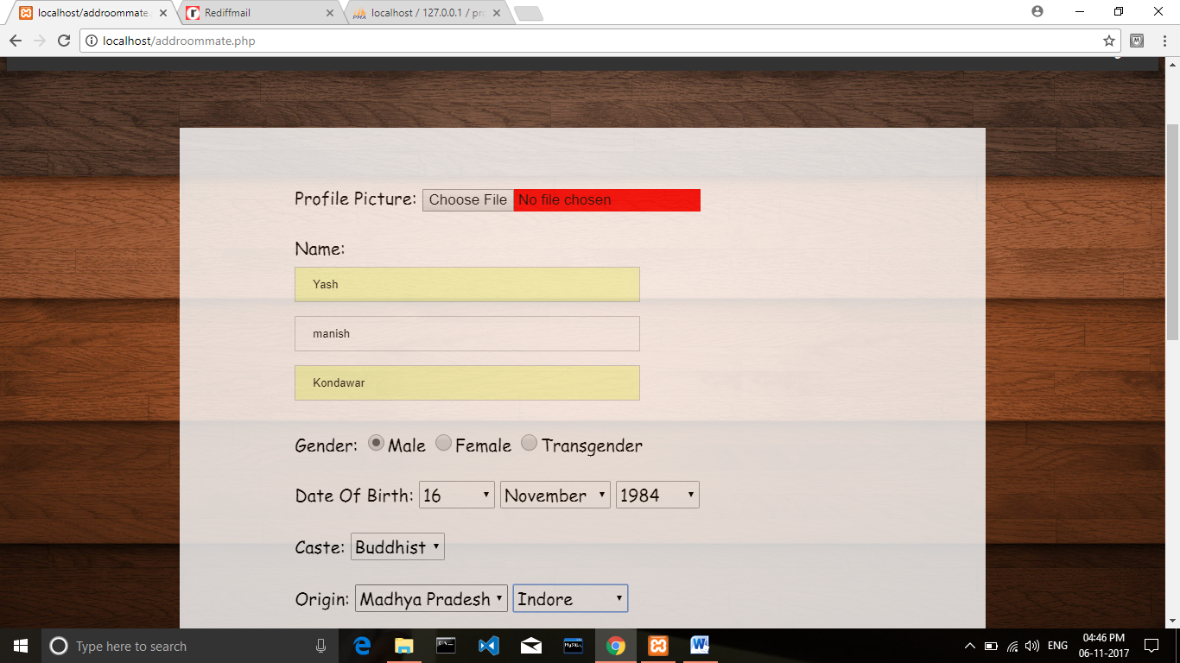

Matched Profiles for PWOF (Contact disclosed):

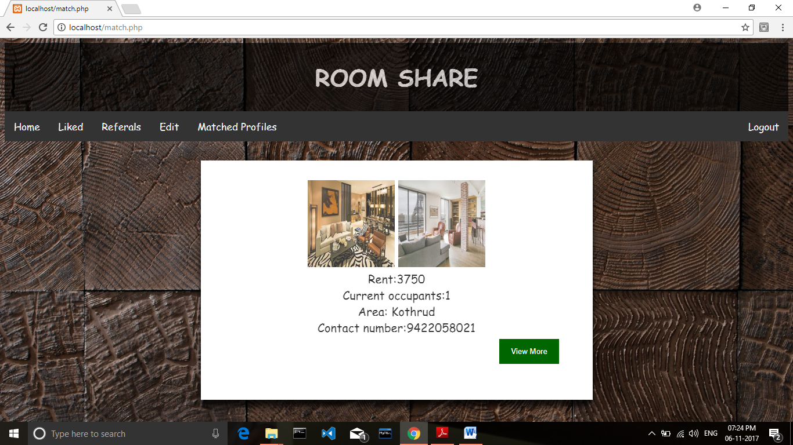

User Feedbacks:

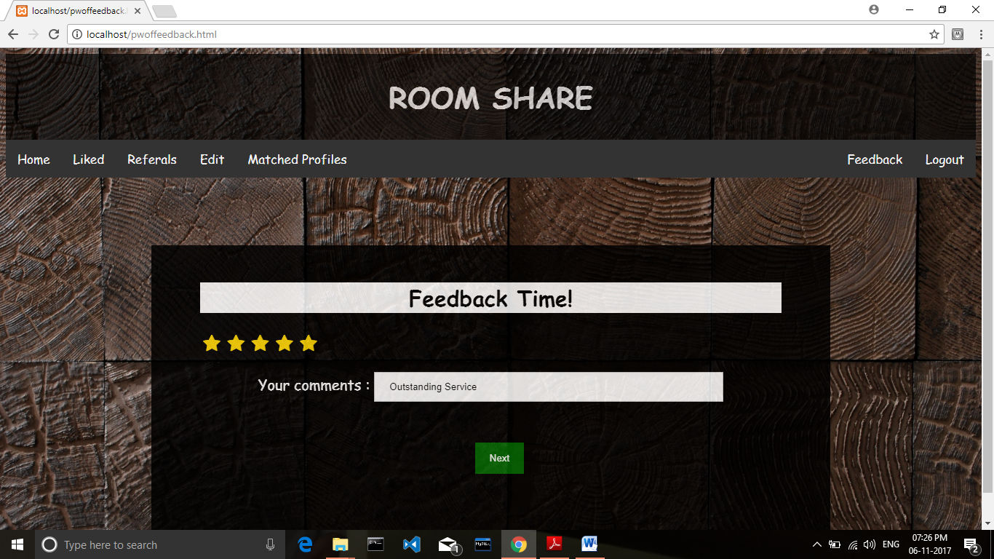

Reports:

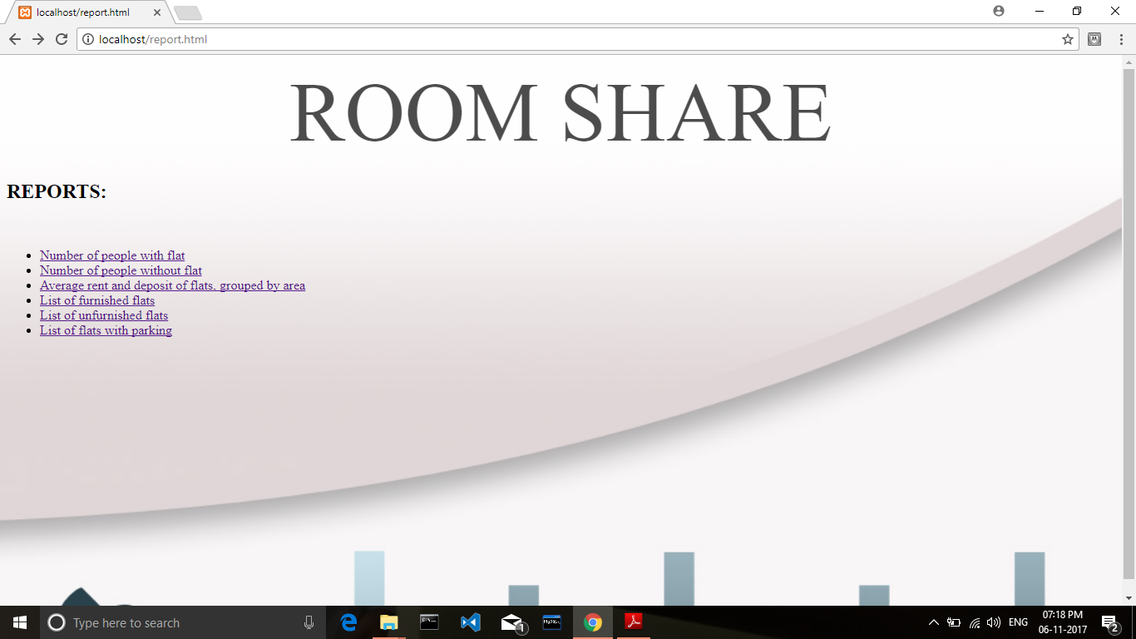

1.

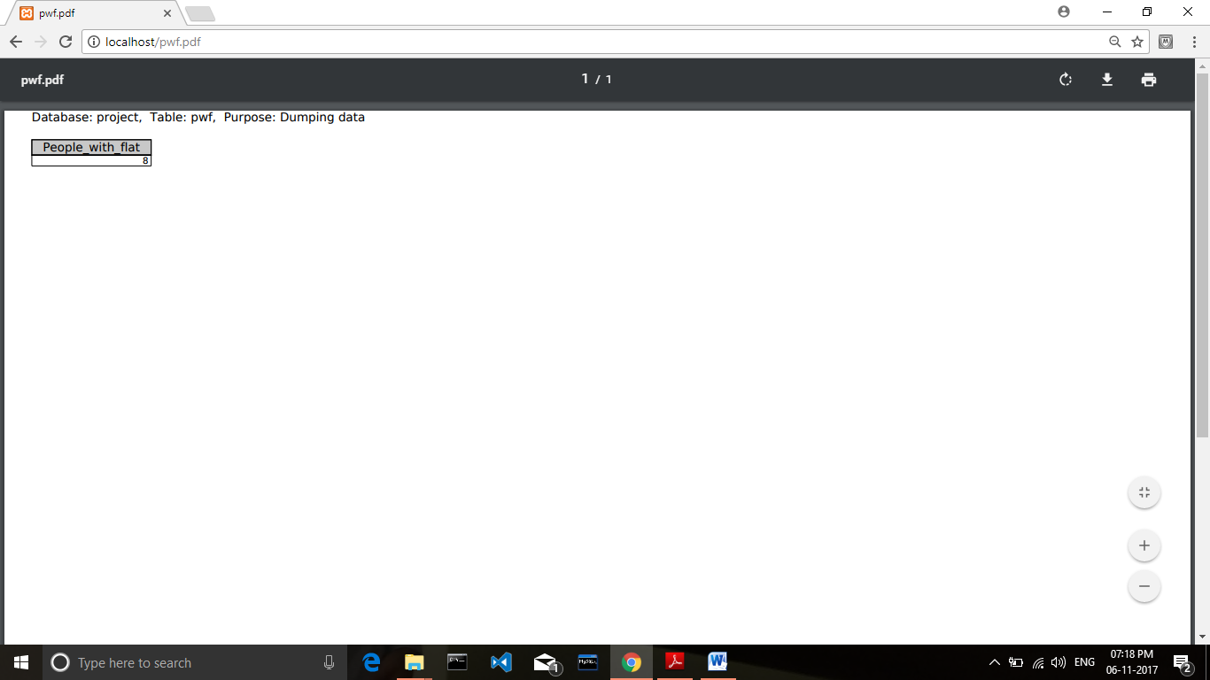

2.

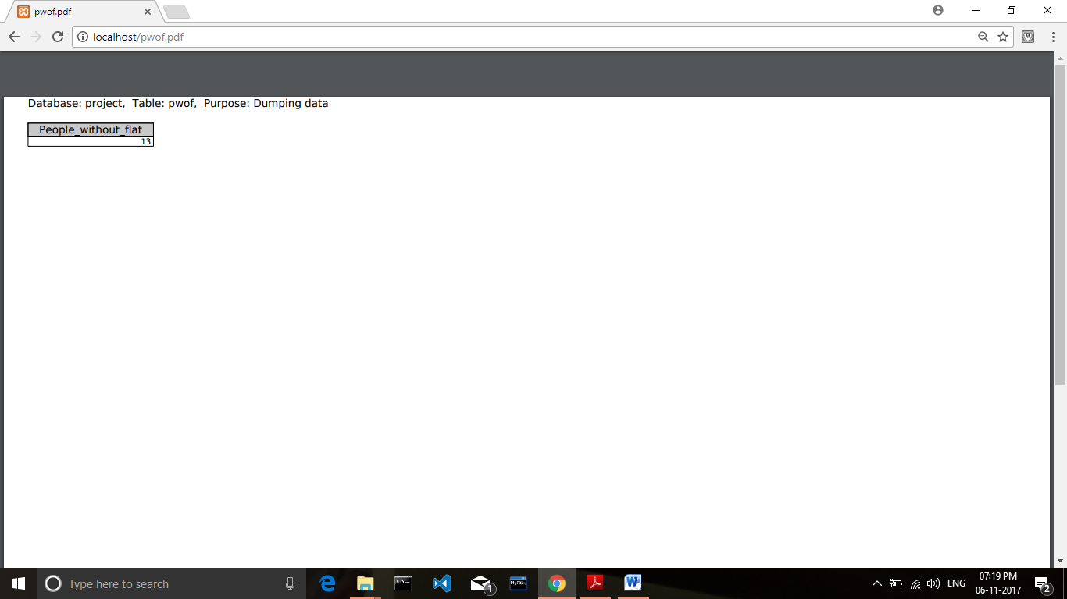

3.

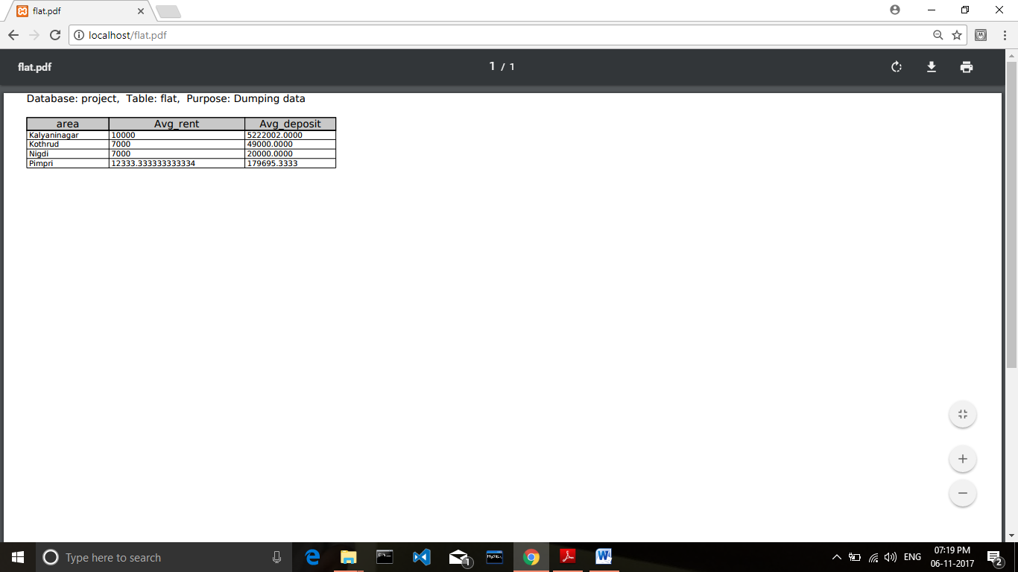

4.

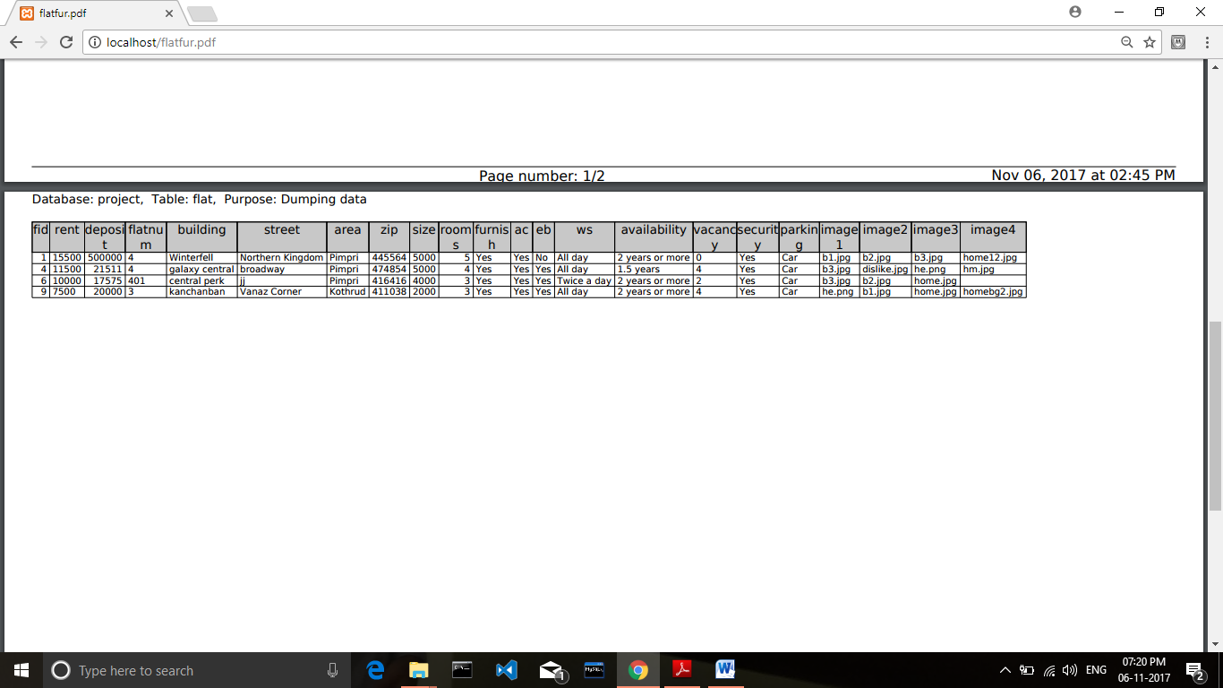

5.

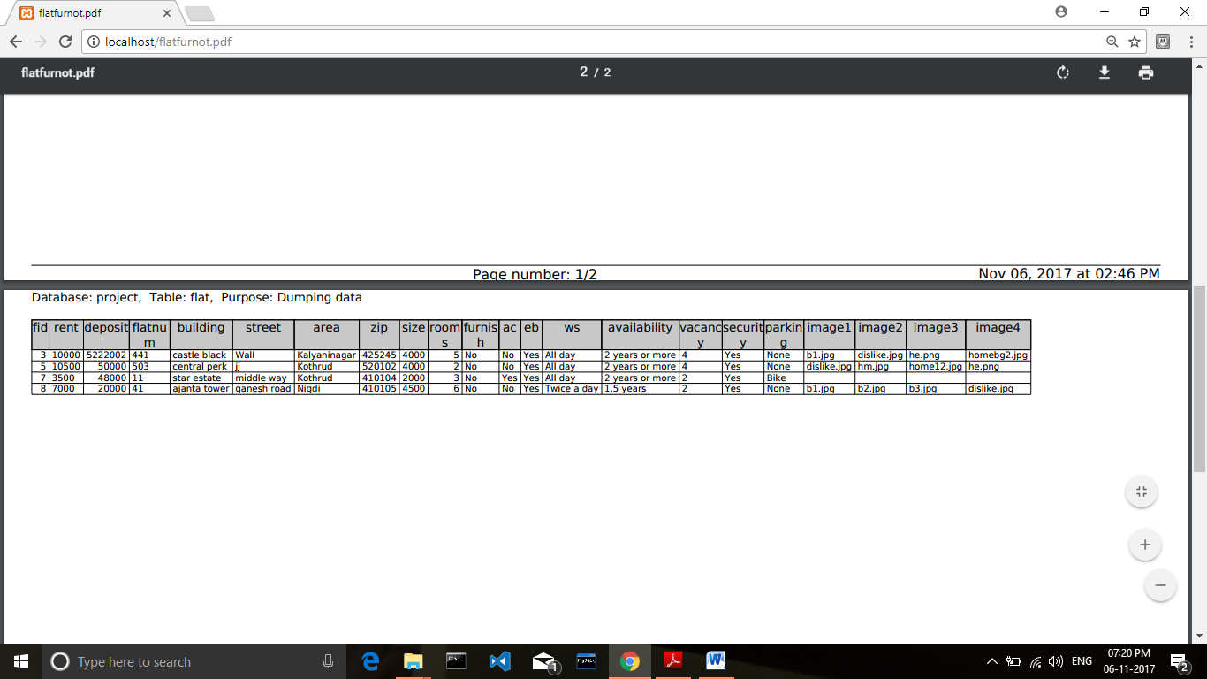

6.

